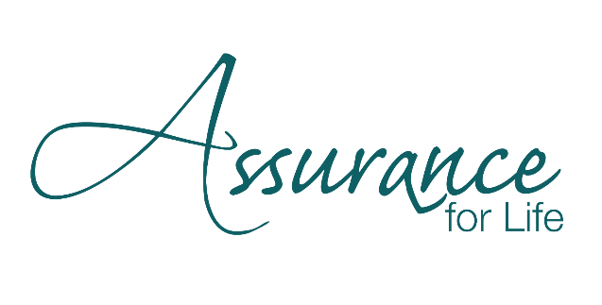

Dear Friend of Assurance for Life:

Exciting plans are well underway for the most important evening of the year for Assurance for Life. We hope you will join us for our **40th Anniversary** banquet on **Monday, October 27th**. You can anticipate the following:

* Hear from our inspirational **guest speaker, Dr. Kathy Koch,** author and Founder/President of ***Celebrate Kids***, which aims to provide parents, educators, and children across the world with biblically grounded practical insights that foster healthy identity, character, and relationships!
* **Updates on God’s work through Assurance** over the last twelve months and where we sense he is leading our organization over the next year.
* **A time of celebration for the forty years** that Assurance has been in existence and ministry.
* **The continual casting of a vision of Assurance that will lead us beyond 40 years.**

Our theme this year is **Psalm 89.2: *I will declare that your love stands firm forever, that you have established your faithfulness in heaven itself****.* It is a theme that points us both backwards and forwards, to his continual call to the work of Assurance.

If you or your business would like to be on the forefront of sharing good news through the work and ministry of Assurance, please consider the following sponsorship opportunities:

|  |  |  |
| --- | --- | --- |
|  |  |  |
| **Sponsorship** | **Donation** | **Our Thank You Includes** |
| **Legacy**  **of Life** | **$10,000** | * Two tables for 10 * Single slide Logo on dinner slideshow & special mention from stage * Logo on table tents & dinner programs for ~470 guests * Large logo poster at event * Logo in the winter quarterly newsletter * Click through link on website * Insert in take home bag * Special mention in the 2026 Annual Impact Report |
|  |  |  |
| **Champion**  **of Life** | **$5,000** | * One table for 10 * Logo on slideshow during dinner & special mention from stage * Logo on table tents & dinner programs for ~470 guests * Medium logo poster at event * Logo in the winter quarterly newsletter * Click through link on website * Insert in take home bag * Special mention in the 2026 Annual Impact Report |
| **Life**  **Changer** | **$1,000** | * One table for 10 * Logo or name listed on dinner slideshow * Logo on Table Tent and Programs for ~470 guests * Listing in our Newsletter * Insert in take home bag |
| **Catalyst** | **$600** | Table for 10 |

To become a sponsor, please visit our website at aflbanquet.org and fill out the sponsorship registration form. We appreciate your partnership and hope that as we move through and beyond our 40th year that you know how much we value and need you to accomplish the work and mission of saving and serving lives across central Kentucky.

In Christ,

Randall Hardman Anna Hogan

Executive Director Event Committee Chair